

Large Scale Digital Design

Design Project Report: Binary Video

# 

# 

# 1.0 Introduction

This documentation records down all the designs and modifications for the project. With the software platform of Altera Cyclone, the main aim is to do thresholding of an image in terms of binary. Overall, the method to accomplish that is by using a histogram consisting of the grayscale pixel values and using it to locate the 50th percentile value which is then inputted to determine the pixels to be coloured either black or white.

# 2.0 Assumptions

1. There are sufficient clock ticks between valid frames to sending the histogram and cumulative histogram and clearing all the histogram used for calculating the counts
2. When dealing with the 50% greyscale, the difference is small enough for the previous frame threshold to work for the next frame.

# 3.0 Basic Requirements

## 3.1 RGB image conversion

Conversion of the RGB camera output image into a 8 bits grayscale image shown on the LCD was done by averaging the summation of all three pixel value of red, green and blue colour.

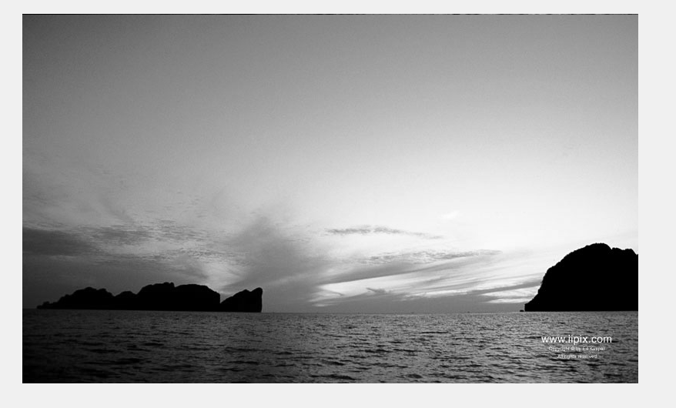

Figure 1: Grayscale image after conversion.

## 3.2 Histogram for grayscale image

The histogram for the image in Figure 1 tends to show between black and white pixels which makes up the distribution of the grayscale image. Black pixels represented by value 0 whereas white pixels is represented as value 255.

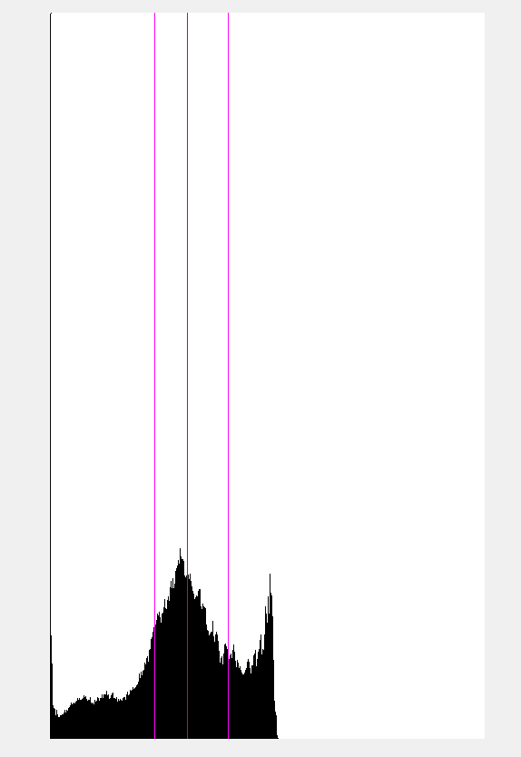

Figure 2: Grayscale histogram.

In Figure 2, the two vertical purple line represents the 25th and 75th percentile line whereas the middle red line is the 50th percentile line. The pixel distribution tends to concentrate more on right side of the graph which can be said to have more black pixels.

## 

## 3.3 Cumulative histogram

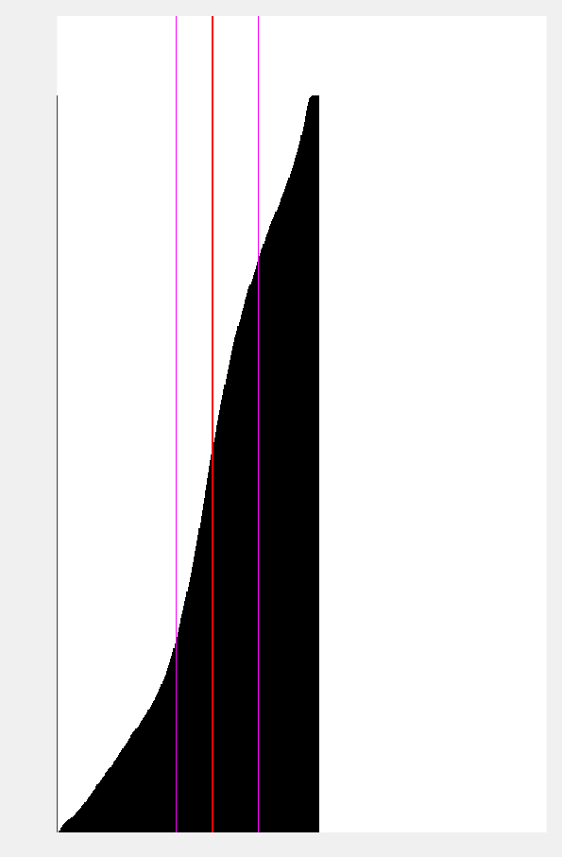

Figure 3: Cumulative Histogram of the image.

Differ from the histogram previously done which only focuses on computing frequencies, the cumulative histogram will cumulatively calculate frequencies as well. A simple finite state machine can be used to represent all the related states of the histogram which includes: Clear Histogram, Building Histogram and Cumulative Histogram.

In Clear Histogram, histogram will be emptied and cleared when there is no buffering of the camera and will check for the frame validity. If valid, then move to the next Building Histogram state.

In Building Histogram, when frame is valid, the histogram frequencies will be begin calculation and will store the calculated results in the ram. Otherwise, will proceed to the next Cumulative Histogram state.

In Cumulative Histogram, frequencies will be calculated cumulatively to find the 50th percentile line which is represented as the red colour vertical line. Practically, cumulative frequencies are just summation of frequencies all together and this can be observed in Figure 3 with the increase in size with respect to the X axis.

## 3.4 Binary Image

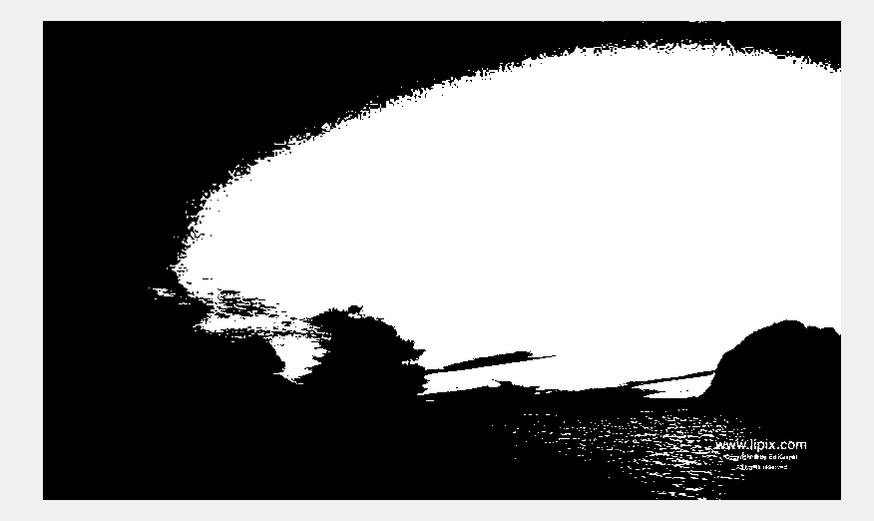

Figure 4: Binary imaging.

The binary image can be done with the thresholding 50% of grayscale image. Compared to the grayscale image, the binary image can still be seen clearly in which the image features of the original grayscale is kept.

# 4.0 Additional Requirements

# 4.1 Accurate threshold frame displaying

The same process as when doing the 50% threshold however the frame is delayed by 1 to ensure that the threshold is shared on the same frame as calculated.

## 4.2 Division of image into subwindows

The division is done by splitting the image in the screen into two equal half windows which the first halved window is applied with 75% of threshold while the other second halved is 25% of threshold.

## 4.3 Interpolation of threshold

The interpolation method uses back the code from the previous Section of 4.2 and interpolates the center bit of the frame. This as a result will cause the threshold of the entire frame to have 75% threshold for the first quarter then followed by the centre part to have 50 % which is gradually falling and the last quarter to have 25%. Image will look improved by doing this interpolation where the aim to smoothen the threshold separation.

# 5.0 Acknowledgement

Skeleton code was provided by Dr Patrick Ho who is the lecturer of the unit ECE 4063 and all online sources such as the Intel FPGA website have been a great help.

# 6.0 Improvements

The calculation for grayscale should be more specific rather than just average the 3 colours. Weighing all colour respectively could help to improvise the grayscale image.